09/10/2025
We built a one-tap “scan → 3D → AR” flow
The goal was to create a simple and seamless demo: point the phone at a picture, tap a single button, generate a 3D model through Meshy, and have that model appear directly on top of the scanned image in augmented reality. The experience was designed to be as minimal as possible — one tap, no setup screens, and immediate visual feedback.
The system is made up of several scripts that work together to make this process possible. Each one has a specific responsibility in the pipeline, from capturing the image and sending it to Meshy’s API, to downloading and displaying the resulting 3D model in the AR scene. Together, these components ensure that the user can go from scanning an image to viewing its 3D representation smoothly within just a few seconds.
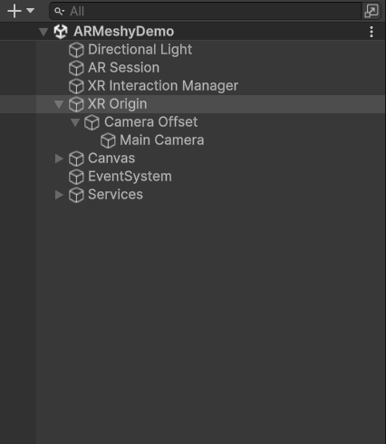

How the scene is put together
The XR OrigWe keep the overall scene structure simple and minimal:
- The XR Origin runs AR Foundation and handles all AR-related tracking and positioning.
- The Canvas contains one main button and a few user interface elements for showing status updates and progress information.
- The Services section is reserved for the network client that communicates with Meshy and the GLB loader responsible for handling 3D model downloads and instantiation.
On the Canvas, there is a single Generate button, which serves as the main entry point for starting the process. Alongside it, there are several supporting UI elements: a loader for indicating activity, a status text for displaying current progress or messages, a progress bar to show task advancement, as well as cancel and retry buttons and an error panel for handling and displaying any issues that arise.
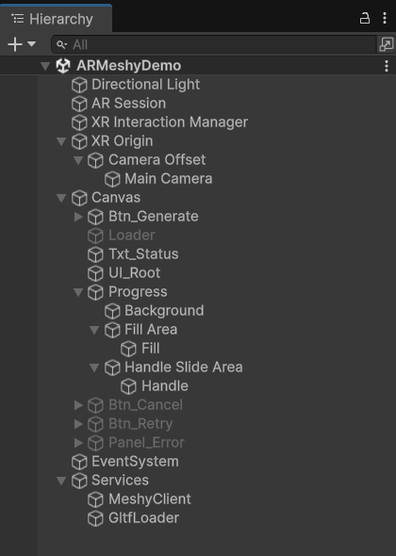

Who does what (the scripts in plain English)
- GenerateController is the main coordinator of the system. It starts the entire process when the user taps the button and ensures that the user interface stays updated throughout the workflow.
- CameraCapture, which is attached to the Main Camera, captures a single CPU frame from the AR camera. It then provides this as both a JPG file and a Texture2D object.
- RuntimeImageLibraryController, located on the XR Origin, is responsible for creating a mutable image library at runtime. It immediately adds the captured image to the library so that the AR system can start tracking that specific image right away.
- MeshyClient, placed under the Services folder, communicates directly with Meshy’s Image-to-3D API. It handles the full cycle: creating the generation task, polling its progress, and finally retrieving the GLB model URL once it is ready.
- GltfLoader, also under Services, downloads the GLB model from the provided URL and instantiates it into the scene using the glTFast library.
- ModelOverlayController, attached to the XR Origin, takes care of attaching the loaded 3D model to the tracked image. It adjusts the model’s scale to match the image’s width, rotates it correctly, and manages whether the model remains locked or unlocked when tracking is lost or regained.
- UIController, which is on the Canvas root, manages the user interface elements. It displays the spinner, shows progress updates, handles cancel and retry options, and presents any error messages that may occur.
- The Spinner itself is a simple component that continuously rotates the loader icon to indicate that the system is processing or loading.

The AR bits on XR Origin
We use AR Plane Manager and Raycast Manager for future interaction features, but the key component here is the AR Tracked Image Manager. Together with our custom scripts, RuntimeImageLibraryController and ModelOverlayController, it drives the core of this flow.
The RuntimeImageLibraryController adds the captured photo to the tracking library so AR can recognize it instantly, while the ModelOverlayController attaches and aligns the generated 3D model to that tracked image, keeping it correctly positioned as the camera moves.
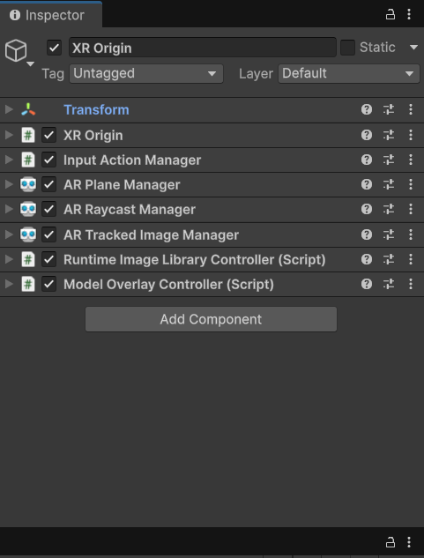
The Tracked Image Manager uses the image library provided by the RuntimeImageLibraryController. This controller begins with a small default library and then replaces it with a mutable version, allowing new images—like the one just captured—to be added dynamically at runtime.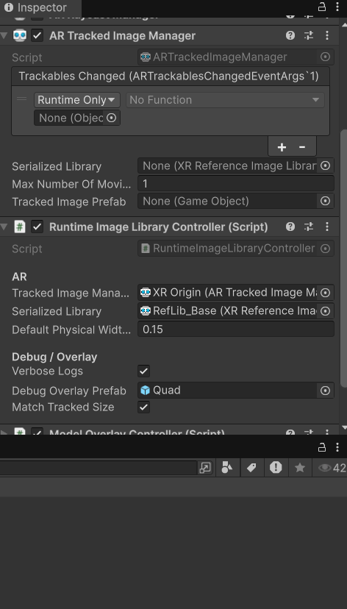
The ModelOverlayController takes care of placement. We match the tracked image width, rotate the model −90° on X so it stands up on the card/page, hide it when tracking is lost, and (optionally) lock to the first seen copy so the model doesn’t jump between duplicates.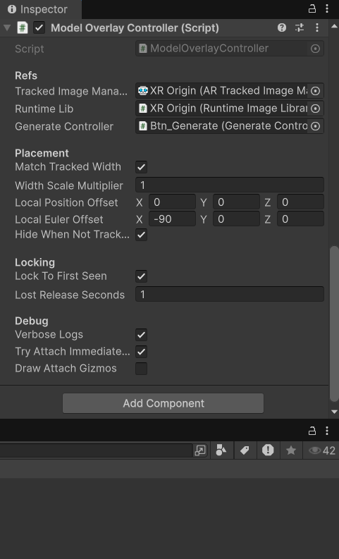

The camera and the button wiring
CameraCapture is attached to the Main Camera alongside the AR Camera Manager. It converts the AR CPU image into a readable Texture2D and a JPG file that can be sent to Meshy for processing. The JPG quality is set to 95 to maintain high visual fidelity while keeping the file size manageable.
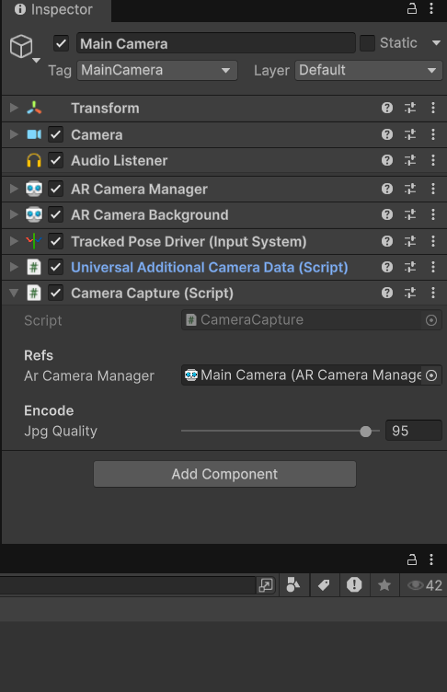
The GenerateController, attached to the Generate button, holds references to all key components: the UI, model overlay, camera capture, runtime image library, Meshy client, and GLB loader. It also defines the physical width for the new reference image, which in our setup is set to 0.15 meters.
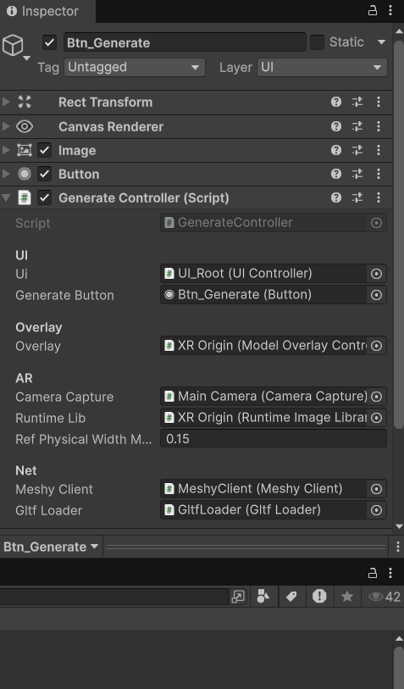

When the user taps “Generate”, the process unfolds as follows:
- The UI switches to a busy state. GenerateController tells UIController to display the loader and progress indicators.
- A still image is captured. GenerateController calls CameraCapture, which provides JPG bytes and a Texture2D.
- The captured image becomes trackable. GenerateController sends the Texture2D to RuntimeImageLibraryController, which adds it to the mutable runtime library with a defined width of 0.15 meters. This allows the AR Tracked Image Manager to recognize the image in real time.
- Meshy is asked to generate a 3D model. GenerateController calls MeshyClient.CreateImageTo3D using the JPG data encoded as base64 and stores the returned task ID.
- The system polls Meshy. MeshyClient.PollImageTo3D continues until the task succeeds or fails. During this, GenerateController updates the progress text and supports cancellation if the user taps Cancel.
- The GLB file is downloaded and loaded. GltfLoader.LoadFromUrl retrieves the file and uses glTFast to instantiate it under a root GameObject.
- The model is attached to the scanned image. GenerateController triggers ModelOverlayController’s TryAttachToCurrentlyTracked(), which finds the matching tracked image, parents the model under it, scales it to the correct width, rotates it −90° on the X-axis, and displays it. If tracking is lost, the model is hidden; if lock mode is enabled, the model stays linked to the first detected image and reattaches when it becomes visible again.
If any step fails, GenerateController instructs UIController to show a clear error message and a Retry option. If the user cancels, the process stops gracefully and the UI resets to idle.

Why this setup works
The mutable runtime image library allows the app to learn and track completely new images instantly, without relying on any preloaded libraries. This gives the experience a dynamic, on-the-spot flexibility that fits the demo’s one-tap design.
The conductor pattern keeps the logic organized. GenerateController manages the entire process step by step, while each specialized script focuses on a single responsibility, reducing complexity and keeping the flow clear.
The overlay controller is independent, which means even if the tracking event occurs before the model has finished loading, the system still attaches correctly. It continuously listens for tracked images and also responds immediately when the model becomes ready through TryAttach.
Finally, the UI controller ensures a smooth user experience by always providing clear feedback showing loading states, progress percentage, and options to cancel, retry, or handle errors.

Small lessons we wrote down
Enabling Verbose Logs in both the runtime library and the overlay scripts makes debugging much easier. It clearly shows when a new image is added, when tracking starts, and when the model attaches.
If a model appears very small or invisible, the issue is usually related to incorrect bounds in the GLB file. To handle this, we calculate bounds based on all child renderers and, if necessary, fall back to a default size before scaling the model to match the tracked image’s width.
The “lock to first seen” feature is particularly helpful when multiple copies of the same printed image are visible. It keeps the model attached to the first detected instance. If you want to switch to another copy, simply move the camera away until tracking is lost briefly, and the model can then attach to the new one.

